June 1, 2020

To Whom It May Concern:

I would like to inform you that Rady Children’s Hospital San Diego applied a 5.01% average increase to the Hospital Chargemaster. The charge increase amount was determined in connection with the development of the 2020-2021 budget that was reviewed and approved by the Executive Committee and Executive Board.



For any questions or concerns please feel free to contact me.

Thank you.

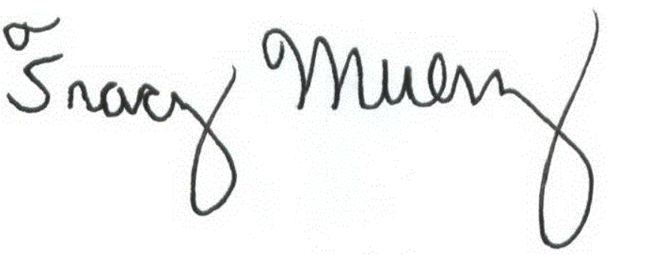

Tracy Muenz

Manager, Revenue Integrity / CDM

Rady Children’s Hospital San Diego